Date:27th-July-2021
Reference Dashboard Design
Below are couple of reference screenshots of a dashboard with differet slicers applied.
2021 Year selected in Year slicer:
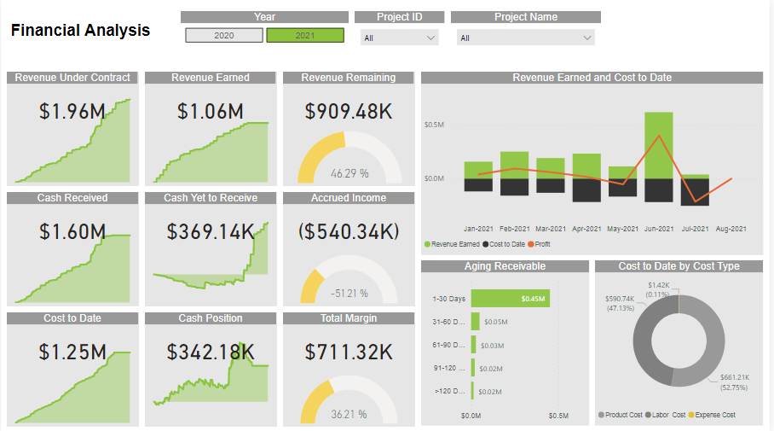
2. 2020 Year selected in Year slicer.
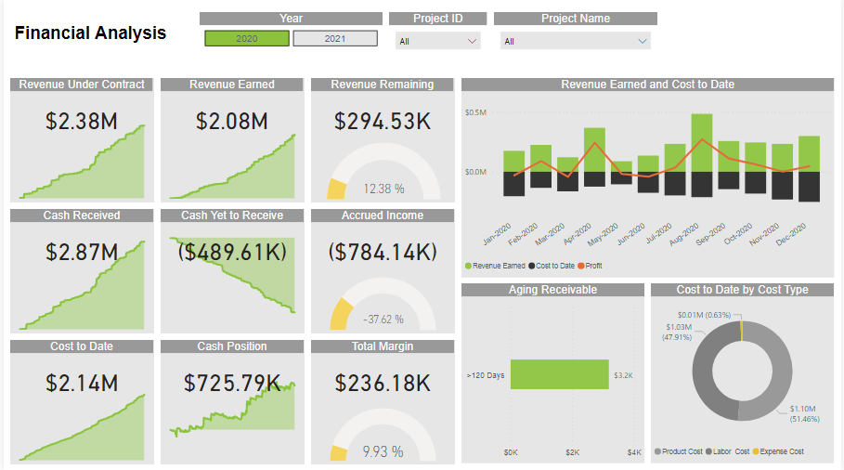

Both 2021 and 2020 are selected in Year slicer:
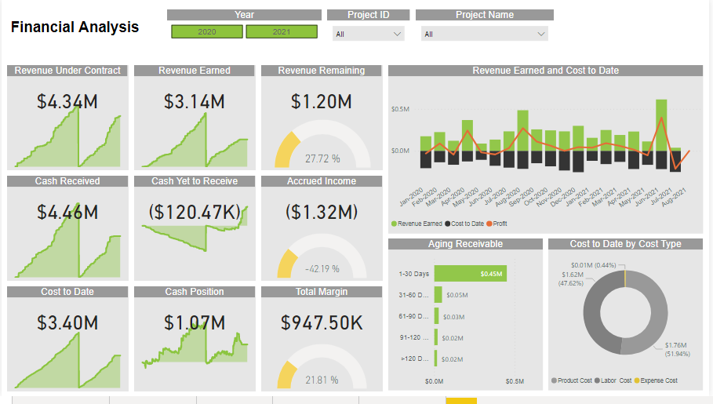
Project ID 568 data for 2021
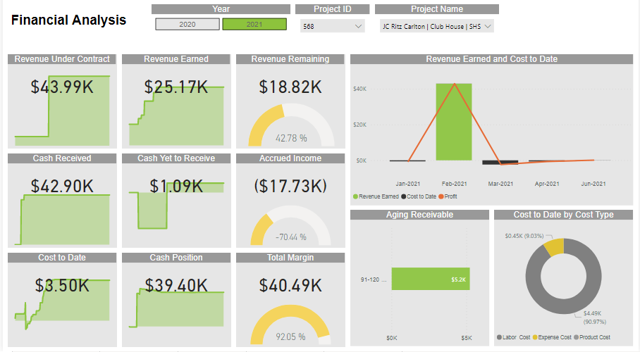
Project ID 568 data for both 2021 and 2020
